Resonance and Q in Electric Circuits

**Name:** Tyler Johnson

**Partner:** Adam Gonzales

**28/03/24**

# Summary

Experiments performed investigate resonance in RLC circuits, and their properties in response to different frequencies. It is shown that expected resonant behaviour is observed in RLC circuits with predicted resonant driving frequencies corresponding with experimentally measured resonant frequencies. RLC resonance demonstrated a magnification factor ( = and a quality factor of ( = 11.125±0.04. These are close but not within error. Measurements for equivalent resistance were not completed, further experimentation is required to verify expected results.

# Introduction

Electrical resonance occurs in electrical circuits at a specific input frequency at which the impedance is minimum. At this frequency, the impedance of the capacitive and inductive components of the circuit are equal in magnitude but are 180 degrees out of phase with each other. Resonating circuits can generate higher peak voltages than the input and reach higher peak currents. Resonant RLC circuits are used commonly in wireless communications, as they are effective at selectively “blocking” frequencies other than the resonant frequency. Understanding resonance is important for circuits containing reactive elements such as capacitors and inductors. The frequency response of a circuit is used in electronics design including power supplies, control systems, music, and communications equipment.

This report will be investigating RLC series circuits and their behaviour at different frequencies. Our aim is to estimate the resonant frequency using known and measured values as well as find it experimentally. The experiments described aim to determine the frequency response of an RLC circuit and find it’s quality characteristics, as well as investigate how frequency affects reactive circuit elements.

# Theory

# AC circuits and impedance

Components in an AC circuit will have a corresponding impedance Z, which is a measure of opposition to an alternating current. For a resistor, the impedance is simply the value of R and is constant regardless of the frequency of AC signal passing through it.

Figure 1: Simple RLC Circuit

For inductors and capacitors, their impedance changes as the frequency ω changes. These are represented as imaginary quantities on the complex plane. The imaginary portion implies a phase shift, a capacitor contributes negative phase shift while an inductor contributes positive phase shift.

Resonance occurs in RLC circuits when the imaginary terms of the circuit’s total impedance cancel out. The total impedance Z() of the circuit shown in Figure 1 can be found.

At the point where , resonance occurs. The impedance of the circuit is purely real and independent of frequency. The resonant frequency can be calculated by solving for angular frequency .

Eq (1)

Our maximum current at resonance can also be calculated as Z() = R.

Eq (2)

# Q Factor, Magnification, and resonance bandwidth

(Hz)

Figure 2: Frequency-Voltage response of an RLC circuit

Q factor, or “quality” factor, is a measure of the bandwidth of the resonant frequency and the magnification of the input voltage at resonance.

is the ratio between the input voltage and the peak voltage across the inductor at resonance.

Eq(3)

Magnification factor is important in determining the maximum voltage generated in an RLC circuit, as this can exceed the input voltage and potentially damage hardware. Voltages generated can become dangerous depending on the input voltage and circuit design.

(Hz)

Figure 3: Graphical representation of resonance bandwidth

refers to the “width” of the resonant peak. More specifically, it is a measure of the range of frequencies between which the circuit is above 50% power compared to the resonant peak. This corresponds to a frequency range of where is the frequency at which the circuit is at 50% power. can be found by determining the point at which the voltage across the inductor reaches , this corresponds a 50% power level as described by the equation for electrical power.

Eq(4)

Eq(5)

# Experimental Methods

# Frequency response of an RLC circuit

The capacitance of the 3.3uF capacitor and resistance of 33Ω resistor are recorded with a Digital Multimeter (DMM) and are recorded for use in calculations. The resistor, capacitor, and a 0.1 ± 0.01 H inductor are connected in a circuit as shown in Figure 2.

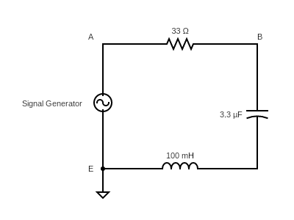

Figure 4: Circuit diagram for frequency response experiment.

The signal generator peak voltage was set to 0.57V. A digital multimeter was connected across the terminals temporarily to verify an RMS of 0.4V. Channels 1 and 2 are connected to points A and B respectively, the oscilloscope was grounded at point E. To verify the setup, the frequency was quickly swept on the signal generator. Channel A was observed to be constant while Channel B was observed to change with frequency. Two DMMs are connected to the circuit shown in Figure 1; one between point A and point B to measure VR ; and one between A and E to measure V0. Measurements are taken at a range of frequencies from 100Hz to 500Hz, including at the expected resonant frequency. Results are recorded in Figure 6 and 7.

# Determining resonance using an oscilloscope

This procedure is useful for experimentally determining the resonant frequency using an oscilloscope. The experimental setup remains unchanged from the previous experiment. Channel A was adjusted such that the waveform crosses zero on the centre line of the display, and the volts/division was turned down such that the lines appear nearly vertical. Channel B was shifted until the peaks of the waveform are close to the centre line. The frequency on the signal generator was adjusted until peaks of channel B line up with the points channel A crosses zero. This indicates a phase difference of between the voltage at the input and the voltage over the inductor. The frequency on the signal generator was recorded and contributes to the previous exercise.

# Measuring Quality Factor

The 33 ohm resistor was removed from the circuit, the new circuit setup is shown below.

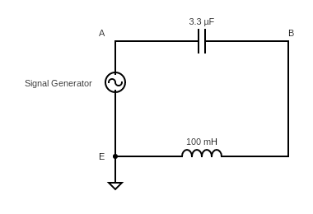

Figure 5: Circuit diagram for Quality Factor experiment.

Using the oscilloscope method described above, the resonant frequency of the circuit was measured and recorded. Voltage measurements were taken using a DMM across the capacitor, inductor, and signal generator at the resonant frequency and recorded. The frequency on the signal generator was lowered until . This frequency was recorded as . The frequency was raised above the resonant frequency until the same relationship was true, this frequency was recorded as . The difference between and was recorded as . All frequency measurements were taken using the reading on the signal generator.

# Measurement of Equivalent Resistance

Using the same experimental setup as in Figure 3, a DMM was used to measure the DC resistance across the inductor. The value of each denomination of capacitor was measured using the DMM and recorded. Using the signal generator and oscilloscope method described previously, the resonant frequency was predicted then measured for each denomination of capacitor. At the resonant frequency for each capacitor denomination, voltage measurements were taken across the signal generator, inductor, and capacitor using a DMM. These values were recorded for later analysis.

# Results and Uncertainty

# Frequency response of an RLC circuit

Table 1: Measured values of circuit components

|  |  |  |
| --- | --- | --- |
| Value | Expected Value | Measured Value |
| Capacitance |  |  |
| Resistance |  |  |
| Inductor |  | Value is given |

Using Eq(1):

Figure 6: vs results

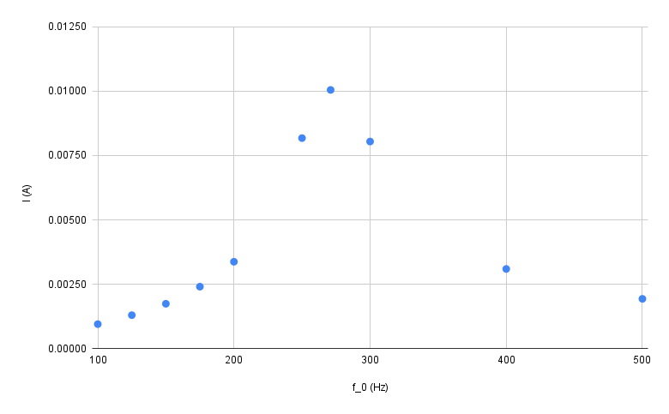Resonant frequency determined using oscilloscope method: .

Figure 7: vs results

Table 2: DMM Measurement results at measured resonant frequency

|  |  |
| --- | --- |
| Value | Measured Value |
| (V) |  |
| (V) |  |
| Eq(2) (A) |  |

# Measuring Quality Factor

Resonant frequency determined using oscilloscope method:

Table 3: Voltage measurements across RC components at resonance

|  |  |
| --- | --- |
| Value | Measured Value (V) |
|  |  |
|  |  |
|  |  |

Using Eq(3):

Table 4: Frequency bandwidth measurements at 0.707

|  |  |
| --- | --- |
| Frequency (Hz) | Measured Value (Hz) |
|  |  |
|  |  |

Using Eq(4):

Using Eq(5):

# Measurement of Equivalent Resistance

Predicting with our quality factor using Eq(3):

Measured DC :

Table 5: Capacitance values measured by DMM

|  |  |
| --- | --- |
| Expected Capacitance | Measured Capacitance |
|  |  |
|  |  |
|  |  |
|  |  |

Table 6: Resonant frequencies for different capacitance values

|  |  |  |  |  |
| --- | --- | --- | --- | --- |
| Capacitance Measured () | Inductance (H) | (Hz) (Calculated) | (Hz) (Measured) | (Ω) (Calculated) |
| (3.286±0.0005) | (0.1±0.01) | (277.643±27.81) | (271±0.5) | (13.023±2.253) |
| (0.307±0.0005) | (0.1±0.01) | (908.345±92.31) | (911±0.5) | (43.778±5.333) |
| (0.0368±0.0005) | (0.1±0.01) | (2623.592±298.01) | (2615±0.5) | (125.664±13.534) |
| (0.0030±0.0005) | (0.1±0.01) | (9188.815±2450.35) | (9208±0.5) | (442.490±45.265) |

# Analysis of Results

# Frequency Response of an RLC Circuit

The predicted value for the resonant frequency is shown in Figure 6 and 7 to correspond to a peak in both voltage across the resistor, and circuit current. Given the large 10% error associated with the inductor, our calculated frequency has an uncertainty of ±27.78Hz, its possible that the circuit resonates more strongly at a frequency within that range. The predicted value was calculated using measured values, these are subject to fluctuating value errors from DMM measurements as well as tolerance errors from manufacturing.

Comparing our expected frequency response in Figure 2 with our measured response in Figures 6 and 7, a definitive peak can be seen at the resonant frequency. This lines up with expected resonance behaviours, with voltages higher than the input voltage being generated across circuit components. For a clearer picture of the frequency curve, more samples should be taken across the 500Hz frequency range. Very few measurements were taken close to the resonant peak, as such it is difficult to tell if the expected resonant peak is the same as our experimental peak.

# Measuring Quality Factor (Q)

Given the definition for described in Eq(3) a magnification factor of 13.075±0.002 was observed, this is consistent with expected behaviour at resonance, as a resonating circuit will generate higher voltages than the driving voltage across circuit components. Voltage measurements for were taken with a DMM to avoid using the value reported on the signal generator, as this was not as accurate as the DMM and would misreport the current voltage. Voltage measurements across both the inductor and the capacitor were the same as recorded in Table 3, this is due to the impedance of the components being relative to frequency. As the circuit is at resonance, the impedances of both components are equal in magnitude but opposite in phase. As the magnitude of the impedance is the same, the voltage generated across the capacitor and inductor is equal.

The range is also determined using DMM measurements across the inductor. The value of was calculated to be 11.125±0.04, this value is expected to be equal to the value of although these are not within margin of error of each other. This can be partially be attributed to the use of measurements taken from the signal generator, as the frequency was not verified and the error is quite large. Inefficiencies can also influence this reading, although given the voltages and current present in the circuit these would be almost negligible.

# Measurement of Equivalent Resistance

Unfortunately, this portion of the experiment could not be completed in full. Time constraints as well as difficulties with hardware during the experiment meant the required measurements for experimentally determining equivalent resistance weren’t taken. Measurements for DC resistance were recorded, and can be compared to predicted values. The measured DC resistance is significantly different to the predicted value of AC equivalent resistance of . This is expected, as the impedance of reactive components in a circuit is dependent of the frequency. The resonant frequency was also calculated for RL circuits with different capacitance values, the resonant frequency was observed to increase as capacitance decreased. Due to time constraints this could not be experimentally proven.

In the future, more careful preparation and planning of the practical class will ensure adequate time to complete the practical. If the practical is not completed, additional time with the hardware should be organised with the unit coordinator.

# Conclusion

Results acquired from the experiments described above effectively demonstrate the concept of resonance, and the importance of the frequency response in RLC circuits. Calculated predictions correspond clearly with experimentally determined values, and fit expected behaviour given the background theory. Values regarding Q factor were inconsistent with each other, likely as a result of improper measurement techniques and failing to verify measurements. Unfortunately, due to time constraints and hardware struggles the full practical was not completed. More investigation is necessary to verify the predicted value with a result found experimentally. More investigation into the discrepancy between Q factors would also be valuable for further insight.

In the future, it would be best to plan and prepare for the practical more thoroughly in advance to avoid time limitations preventing completion of the practical. If more time was allowed, further measurements could be taken to verify the frequency response of the initial RLC circuit, as well as completing the equivalent resistance portion of the experiment.

The experiments accurately addressed the aims of the report, with the exception of investigating equivalent resistance.

# Acknowledgements

I would like to acknowledge and thank our convenors for this unit, Alexei Gilchrist and David Spence, for their hard work on the unit and clear communication. Special thanks to Adam Joyce the lab manager, who helped with understanding results and diagnosing hardware issues during the practical.

A thank you to my fellow students present in the lab, with whom we compared results to make sure we were on the right track.

And of course a thank you to my lab partner Adam, who helped immensely in the lab and with preparing the lab report.